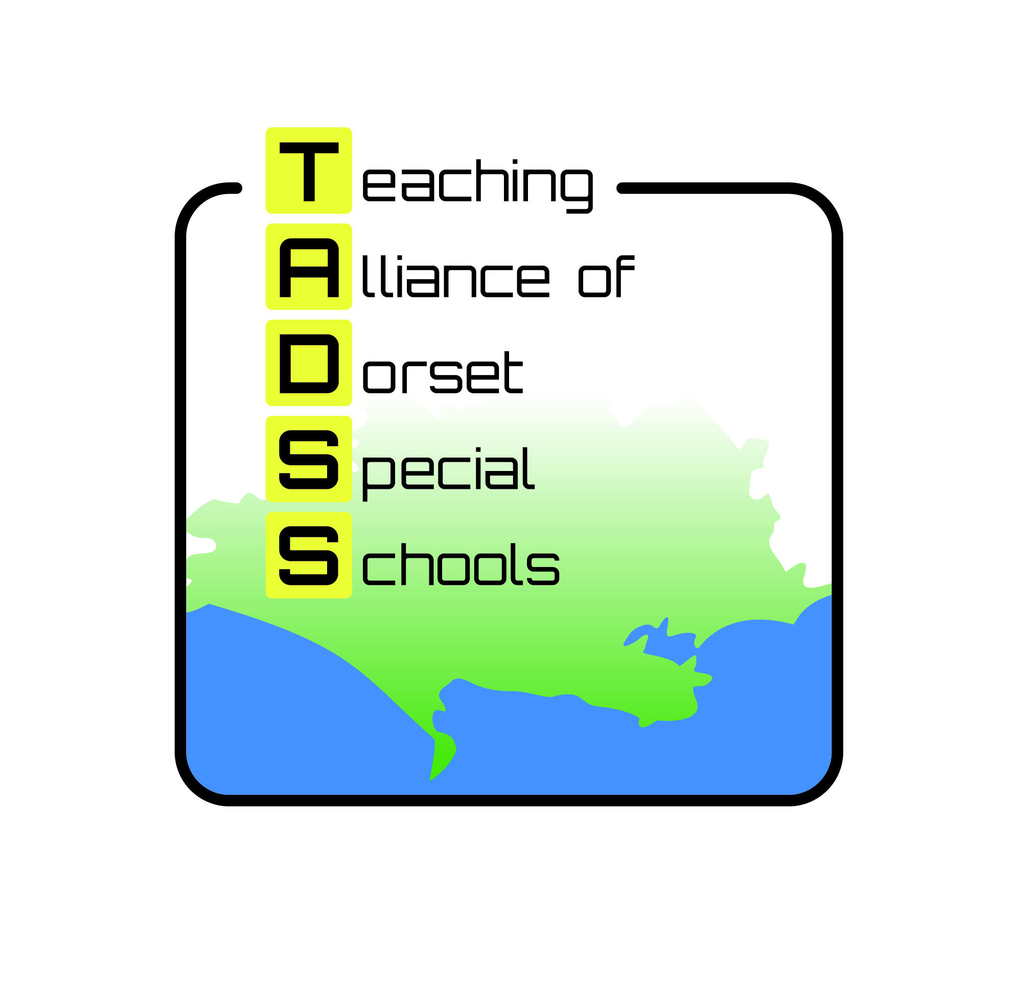
Teaching Alliance of Dorset Special Schools
c/o Westfield Arts College
Littlemoor Road Weymouth DT3 6AA
Email: tadss@westfield.dorset.sch.uk Tel: 01305 833518

LGBT+ Inclusion in Schools and SEND
Wednesday 4th May 1pm -3pm
Moreton Village Hall, The Common, Moreton, Dorchester DT2 8RE
Fees: £40 per delegate

How to book: Please fill in booking form and return to
bookings.tadss@westfield.dorset.sch.uk

Please use one booking form per delegate
Title |  | First Name
Surname

Job Title

Organisation

Address
Day Tel Number |  |  | Home Tel Number  For emergency purposes only
Email address

Special requirements

Cheque enclosed
Please quote purchase order no.:
Please send invoice to:
Name:
Address:

Payment terms:
All payments must be received prior to event.
Cheques should be made payable to: Westfield Arts College
BACS - Sort code 20-26-62, Account number 30097993

Invoiced payments must be made with immediate payment terms.

Cancellation:
Cancellations made in writing to TADSS within 21 days of the conference/workshop will be refunded, less an administration fee of £15.00.
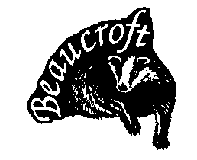
Unfortunately cancellations after this date will not be refunded. However organizations may change the name of the delegate at any time. If you do not cancel and do not attend, no refund will be made. If for reasons beyond our control all or part of the workshop is cancelled then workshop fees will be refunded after deduction of expenses already incurred.



Beaucroft Foundation School Mountjoy School Westfield Arts College Wyvern Academy Yewstock School

