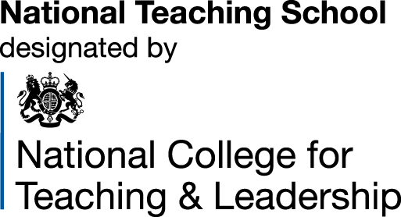
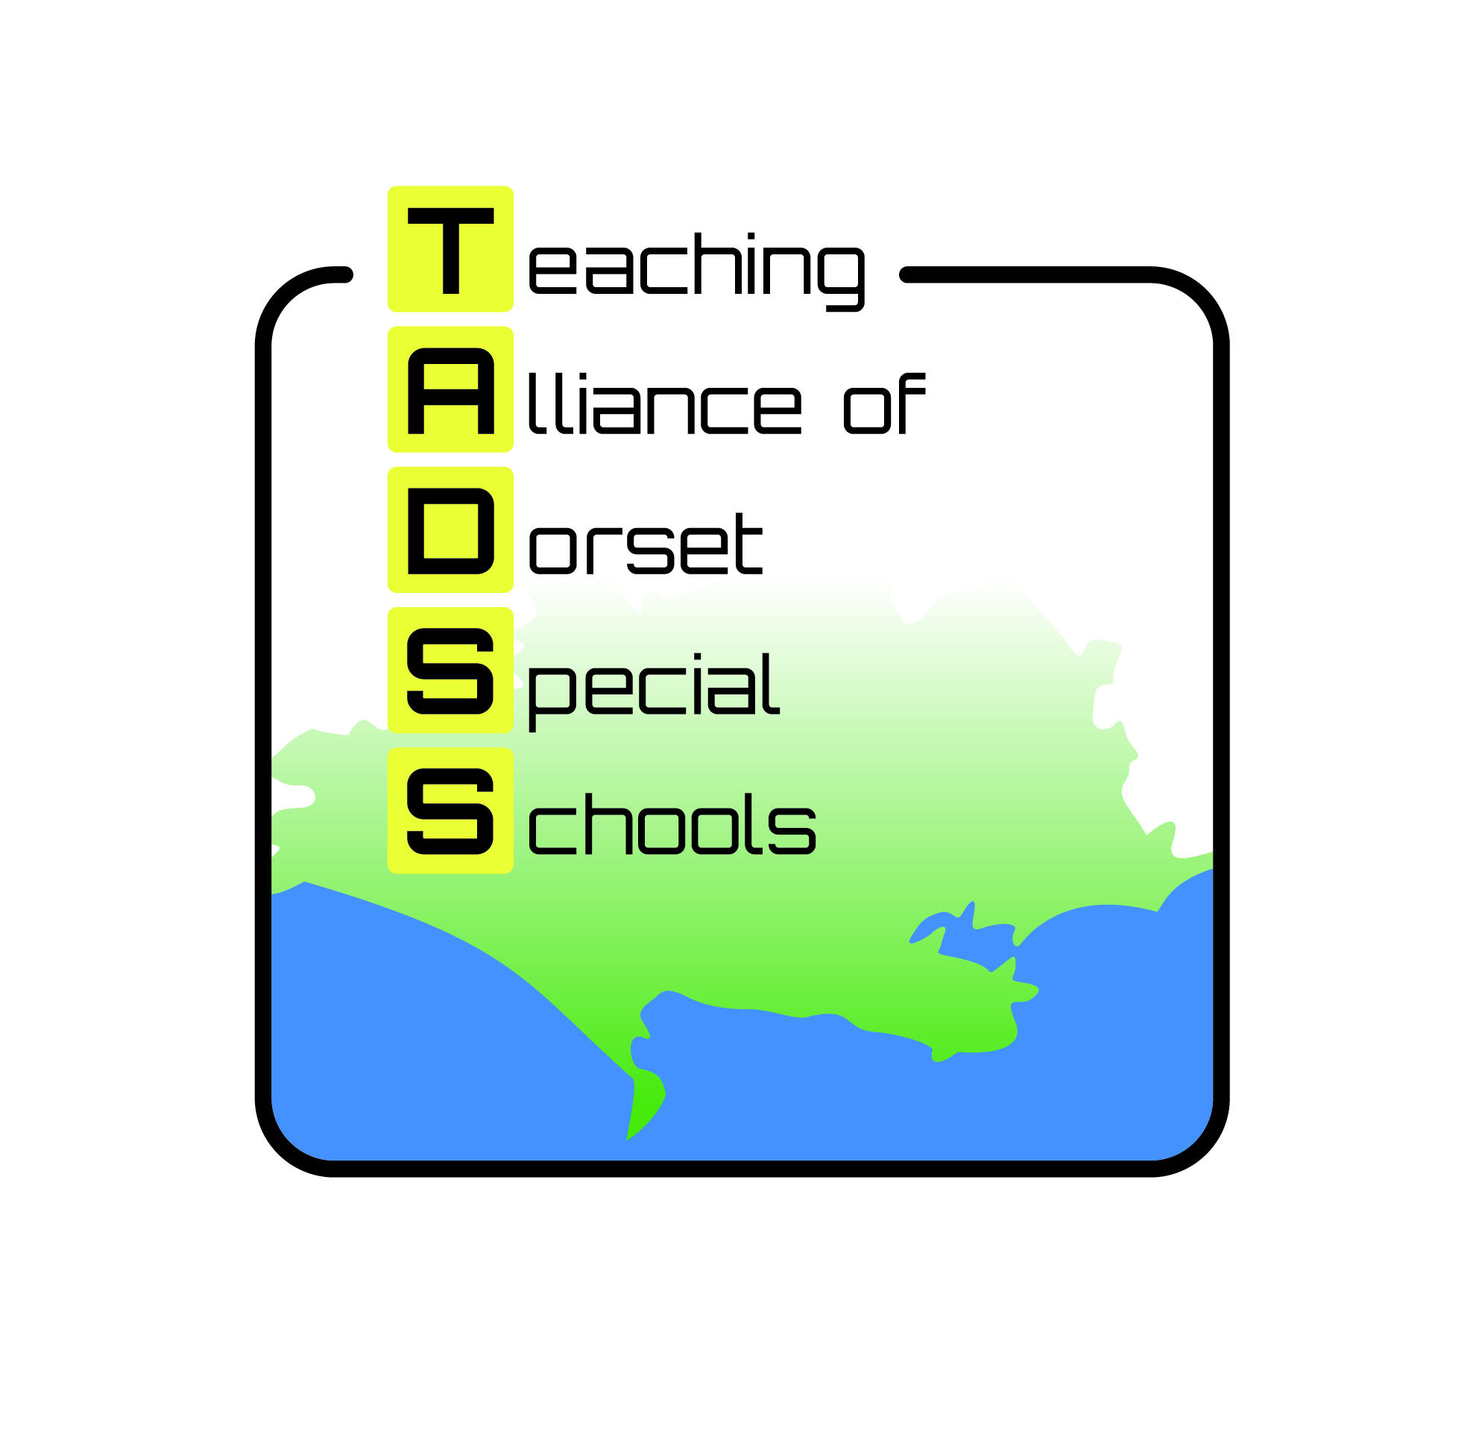
Teaching Alliance of Dorset Special Schools
c/o Westfield Arts College
Littlemoor Road Weymouth DT3 6AA
Email: tadss@westfield.dorset.sch.uk Tel: 01305 833518

Booking Form: Attachment Seminars – Online

Please indicate which of the following seminars you would like to attend.

Attachment and Developmental Trauma - 14th & 28th May 2pm – 3:30pm (£60)
Strategies to Support Successful Transitions for All Pupils – 25th June & 2nd July 1:30– 3:30pm (£60)
Impact of Attachment Difficulties on Learning and Behaviour – 11th June – 1:30 – 3:30pm (£30)
If you book all 3 seminars you will be charged £100. 2nd and subsequent bookings from the same school will receive an additional 20% discount on all bookings.

How to book: Please fill in booking form and return to:
TADSS, Westfield Arts College, Littlemoor Road, Weymouth, DT3 6AA
Telephone 01305 833518 Fax 01305 835414
or email this form to : bookings.tadss@westfield.dorset.sch.uk

Please use one booking form per delegate

First Name |  | Surname
Job Title

Organisation

Address
Day Tel Number |  | Home Tel Number  For emergencies only
Email address | [Please put email of delegate not the person booking the course]

Cheque enclosed
Please quote purchase order no.:
Please send invoice to:
Name:
Address:

Payment terms:
All payments must be received prior to event.
Cheques should be made payable to: Westfield Arts College
BACS - Sort code 20-26-62, Account number 30097993

Invoiced payments must be made with immediate payment terms.

Cancellation:
Cancellations made in writing to TADSS within 21 days of the conference/workshop will be refunded, less an administration fee of £15.00.

Unfortunately cancellations after this date will not be refunded. However organizations may change the name of the delegate at any time. If you do not cancel and do not attend, no refund will be made. If for reasons beyond our control all or part of the workshop is cancelled then workshop fees will be refunded after deduction of expenses already incurred.

Beaucroft Foundation School Mountjoy School Westfield Arts College Wyvern Academy Yewstock School

